DRAFT LEGAL INFORMATION SHEET
Yarrawonga Sprint – 21st October 2017

The AUSTRALIAN RACE COMPETION RULES will apply for the YMMF Triathlon SPRINT DISTANCE – Age Group Draft Legal event to be held on 21st October 2017:

TA Race Competition Rules (July 2017) the following Rule advises:
Rule 3.15 In all draft legal events for Age Group competitors, the ITU Competition rules * apply including, but not limited to:
- Wheels shall have at least 12 spokes;
- Disc wheels and/or disc brakes are not permitted in draft legal events
- Only traditional drop handlebars are permitted.
- The handlebars must be plugged;
- Clip-ons are not allowed.
ITU Competition Rules can be downloaded from (www.triathlon.org
UCI Approved equipment can be downloaded from
(http://www.uci.ch/inside-uci/rules-and-regulations/equipment-165067)

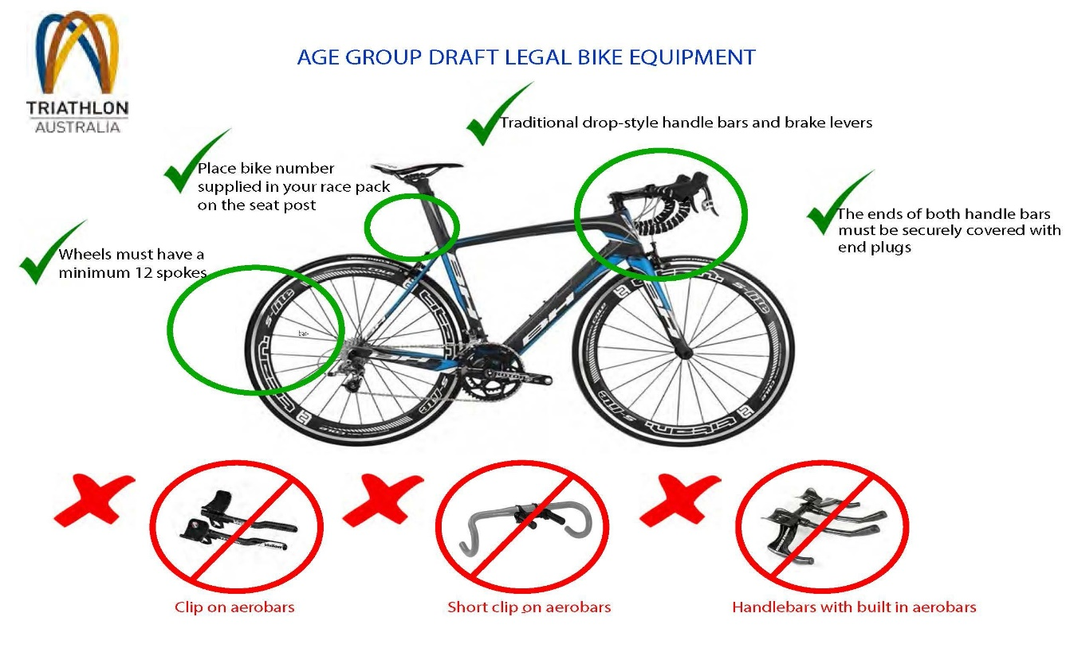

ITU Competition Rules (08/12/2016) Rule 5.2. Equipment:
d.) For draft-illegal events, and Age Group draft-legal events:
(i) Frames:
- The bike will be no more than 185 cm long, and 50 cm wide;
- The bike will measure between 24 cm and 30 cm from the ground to the centre of the chain wheel axle;
- There will be no less than 54 cm and no more than 65 cm between a vertical line passing through the centre of the chain wheel axle and a vertical line through the centre of the front wheel axle;
- The frame of the bike shall be of a traditional pattern, i.e., built around a closed frame of straight or tapered tubular elements, (which may be round, oval, flattened, teardrop shaped or otherwise in cross-section) Bikes built around a diamond shape (no saddle down tube) or with a rear triangle which does not connect at the top of the down tube/top tube section are considered acceptable.
- Bikes provided with the UCI Time Trial homologation label (Code TT) are always allowed in ITU draft-illegal events, even if they contravene any of the 5 first bullets in this 5.2 b) (ii) insert.
(ii) Saddle-position:
- There will be a vertical line touching the front-most point of the saddle which will be no more than 5 cm in front of, and no more than 15 cm behind, a vertical line passing through the centre of the chain wheel axle, and an athlete must not have the capability of adjusting the saddle beyond these lines during competition;

ITU Competition rule . Rule 5.2. Equipment:
e.) Wheels:
(vii) For Age Group draft-legal competitions, wheels must have the following characteristics:
- Wheels shall have at least 12 spokes;
- Disc wheels are not allowed
f.) Handlebars:
(ii) For Age Group draft-legal competitions, the following handlebar rules will apply:
- Only traditional drop handlebars are permitted. The handlebars must be plugged;
- Clip-ons are not allowed.

For your information as per the ITU Draft Legal rules the following penalties will apply
"Discard equipment" or littering.
Penalty: 10 seconds in Run Course Penalty Box
Transition Infringements. Rack the bike improperly, unfastened helmet, or mount/dismount line.
Penalty: 10 seconds in the Run Course Penalty Box.

Bike Course Infringement. Fail to ride on LHS when not in a pack.
Penalty: 10 seconds in Run Course Penalty Box
Bike Course Infringement. Drafting within 10m off a different wave competitor or M/C.
Penalty: 1st offence is 1 minute in Run Course Penalty Box, 2nd offence is DQ.

Note Also TT helmets are not permitted

Race Organiser
Yarrawonga Mulwala Multisport Festival

